**Research on Membership/subscription management**

**(Tracking)**

**Made by Karina Karushkova**

In this research I am mainly giving examples on different software systems, services which can help with the management of memberships in a subscription based application or website.

1. **“Wild Apricot”** – “web-based software for small associations and non-profits to help manage membership, website, events, and other activities. It runs through a web browser without needing to install anything on your local computer. Their focus is small organizations and they have a mix of free and paid options. The free option is free for one admin and up to 50 members. They charge $25/month when you get to 250 members.” (Morpus, 2018)

**Pros/Cons** – “…good support (and has some great resources and user reviews), even with the free option, and is very customizable. However, if your organization grows rapidly you will quickly outgrow the free version and have to pay monthly fees.” (Morpus, 2018)

**Features**:

* Automated membership renewals
* Member database
* Membership applications
* Membership database customization
* Widgets for your website



1. **“Admidio”** - It is an open source management software, that focuses on general management/ memberships and events. The functions and features that Admidio has, can vary form list creating of members to online posts and advertising.

**Pros/ Cons** – “Admidio covers many of the key features of membership management software. It can keep your lists updated, integrates with Excel and can export in .pdf format, and it allows posting online and advertising to your member lists.” (Morpus, 2018)

“However, it does not come packaged with many of the bells and whistles included with other software options, such as Wild Apricot. It does not include payment processing, automatic renewals, or accounting. You may want to consider additional software to supplement these functions.” (Morpus, 2018)

**Features:**

* Event notifications
* Excel integration
* Member database
* Member profiles

1. **“MembersGear”** - “free open source membership software that provides you with all the tools to easily administer a membership or subscription web business. Its PHP software allows you to integrate and configure your own design with their management system.  MembersGear also offers paid plugin features, if you decide to expand your uses of the software.” (Morpus, 2018)

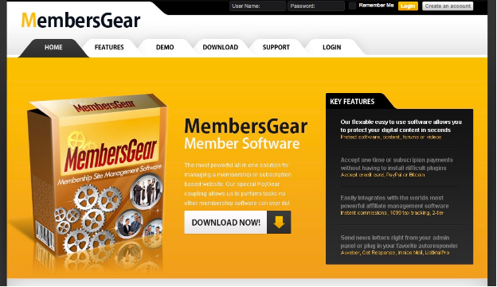

**Pros/Cons** – “It supports member affiliate programs, unlimited groups, and product selling. It’s free and downloadable and is ideal for managing a subscription-based membership website/ application. “ (Morpus, 2018)

“However, although free, is limited given that it’s open source, and unless you are tech savvy you may encounter some problems.” (Morpus, 2018)

**Features**:

* Dashboard
* Excel integration
* Member database
* Member email notifications
* Website widgets and plugins

1. **“Tendenci**” – “in-depth open source software solution, covering the major features of membership management, such as payments, membership lists, donations, and email integration.” (Morpus, 2018)

The full version of the software is available for download on GitHub!

**Pros/ Cons** – “Tendenci is feature- and option-rich, to be sure. However, as with all open source software, it does require some technical expertise to get it up and running. That said, if you don’t want to handle implementation yourself, hosting and support are available as packages purchased on the Tendenci website.” (Morpus, 2018)

**Features:**

* Email marketing
* Event registration
* Jobs board
* Member database
* Member subgroups

1. **“PayPal”** can also provide the company or organization with a system that tracks members.

For example on the official PayPal developer’s website there is this: (Developer.paypal.com, n.d.)

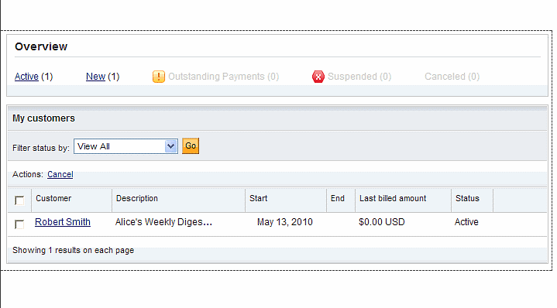

The Recurring payments dashboard is broken down into the following two sections:

* Overview

This section provides shortcut links that allow you to quickly change the dashboard list based on the status value displayed in the link. Additionally, each shortcut link also displays the number of plans that exist with that status value.

* My customers

This section displays the list of recurring payment plans. By default, the list displays all billing plans. Use the Filter status by drop-down menu to only show plans with one of the following status values:

* Active
* Suspended
* Completed
* Cancelled
* Pending Cancellation
* Outstanding payments
* New
* Billed
* To be billed

This is useful if the application or website uses PayPal as a payment method. I wrote more about PayPal in my previous research (Week 2)

BIBLIOGRAPHY:

1. Morpus, N. (2018). The Top 9 Free and Open Source Membership Management Software Products - Capterra Blog. [online] Blog.capterra.com. Available at: <https://blog.capterra.com/top-7-free-open-source-membership-management-software-products/>

[Accessed 17 Oct. 2018].

1. Developer.paypal.com. (n.d.). Recurring payments dashboard - PayPal Developer. [online] Available at: https://developer.paypal.com/docs/classic/paypal-payments-standard/integration-guide/recurring-payments-dashboard/#open-the-recurring-payments-dashboard [Accessed 17 Oct. 2018].
2. Wild Apricot Blog. (n.d.). #1 Free Membership Management Software for Small Organizations. [online] Available at: <https://www.wildapricot.com/blogs/newsblog/2017/01/31/best-free-membership-management-software>

[Accessed 17 Oct. 2018].